Saint Mary’s Anglican Church, Gordonton. Sun 29th Sep
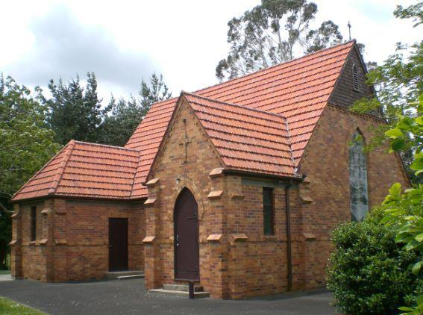
Parish Office Hours & Contacts
Office Hours: Most Fridays 9am to 3pm
Email: stmarysgordonton@hotmail.co.nz
Web: www.saintmarysgordonton.azurewebsites.net
Vicars Phone: 027 4213200 Fridays or 07 8492761 A/H
Vicar: Rev. David Smithson
Peoples Warden: Sally-Ann Riddell 07 8243850
Vicars Warden: John Heaton 07 824 3996

10:00 am Family Communion Service
Homily: Rev. Margaret Trousdale
Parish Lunch at Woodlands after the service

Saint Mary’s Gordonton is by and large a rural parish. I want to take a moment to reflect on the farmers of our community. They are in fact not only the back bone of our community, but of our country and are unsung heroes. Our farmers have been copping a lot of flak lately, but I hail them as keepers of the land, who do wonders for both the economy and for conservation. God bless you farmers – you are outstanding in your field!
God bless, David.
Readings & Intercessor for 29th Sep:

OT: Jeremiah 32:1-3a , 6-15
NT: 1 Timothy 6:6-19
Gospel: Luke 16:19-31

Reader: Trish Smithson
Intercessor: Sally-Ann Riddell
co
Children: Kids activity packs are available with a chocolate treat

Grief Share Support Group:
A special weekly seminar and support group designed to help you rebuild your life after losing a loved one.
Wednesdays until 13 November, 7.00-9.00pm
West Hamilton Community Church
27A Rifle Range Road, Dinsdale, Hamilton
Contact Mary Elliot-Hogg 021 214 3115

Foodbank: Current needs are tinned baked beans & tinned spaghetti, sandwich fillings, pasta, tinned pasta sauce.

+ Prayer Points +

- For the ongoing spiritual battle around us, thanking God for His victory and His angels that protect us
- For David and Mel as they attend Synod this weekend
In case of an emergency during a church service, please note the nearest exit: Front porch entrance and the side door to the vestry office. Fire extinguishers are also located near these two doorways.

