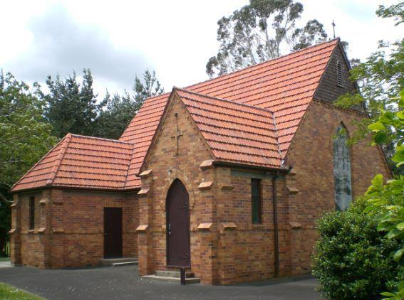
Saint Mary’s Newsletter: April
Vicar: David Smithson 027 4213200 Fridays
07 8492761 Afterhours
Peoples Warden: Sally-Ann Riddell 07 8243850
Vicars Warden: Roger Jennings 07 8243712
SERVICES FOR APRIL

Sunday 3rd:

10am Family communion Service

Refreshments – Brenda Kebbell

Sunday 10th:

10am Baptism & Family communion Service

Refreshments – Katy Cockerton

Sunday 17th:

10am Praise Service.

Refreshments – Daljit Singh

Sunday 24th:

10am Family communion Service

Refreshments – Stephanie Langdon

Monday 25th:

10am ANZAC Service at Gordonton Hall and Cenotaph – please bring a plate

Salt & Light: A bible study group is starting up soon and covers everything from the beginning and beyond! See the vicar for more info if you are interested.

ANZAC Service: 10AM at Gordonton Hall Please bring a plate. We also require at least 5 volunteers to read out names from the roll of honour – please see the vicar
Children’s Church/Junior Youth: This month –Children’s church/Junior Youth is on the 17th.
Youth Group (Year 9+): Combined churches youth Meet Fridays 7pm at Oaks Church Gordonton.

ON PRAYER: There is no one time that prayer is required nor is there just one place. Prayer is something that you may engage in more than you think. It could simply be a prayer that your children will arrive safely at school, or a prayer that your spouse will be able to get off work in time to pick the kids up from daycare or school, or that you will be able to attend a child's recital.
And, while each of these kinds of prayers may not be specifically addressed to God, they are a reflection of one's prayers that continue to enter your life on a daily basis.
So, what does prayer mean in these situations rather than prayers that are more formalized in a particular way or in a particular location such as a church?
Prayer means that you have placed God at the forefront of your life and when you send messages of caring, desire, concern you are in reality communicating with God. God hears your concerns, thoughts and hopes without judging or without a need to hear your prayers in a formal way.
There are prayers that thank God for all the blessings we have including our freedom to worship when and where we want, to thank God for allowing us to love, to care, and to in turn be loved by others. There are prayers that ask for forgiveness, that asks for guidance during times of strife or unrest, or prayers for others throughout the world seeking more peace and tranquillity or food to sustain life, or to ask for the goodness of other nations to help other mankind.
In each of our prayers, there is always a special communication that supersedes that which we can touch, see or envision as part of our worldly state. Prayers go beyond that which often we can understand or contemplate for there is a master plan that we only touch upon without knowing the huge picture that is unforeseen.
Prayer continuous on a continuous basis for each of us who understands and values the grace and power of our supreme being.
When you engage in prayer, you are exercising a control over your life that no one can take away. You do not have to pray out loud like you may be requested to do in a church. You can pray silently during the day by taking a short mind break where you open your communication with God. You can pray when you are walking through the bush, or in a park, or in a movie theatre. There is no need to be recognized as praying if you should live in a country where your prayers are not welcome. You can also engage in leading a prayer if you are asked to make a blessing over dinner, or to pray with your children before they fall to sleep. You have an open line of communication with God and one that cannot be denied nor taken away.
Parish Giving
Please consider giving to the parish via Automatic Payment. Did you know that St Mary’s has to pay for our Vicar and all other costs of running a Parish, as well as giving a proportion to the Diocese? Please help us to be sustainable by giving via Automatic Payment. It is an easy way to give and is useful for the parish in running its budget. The Parish Bank Account is:
02 0410 0103053 00
This Month in Christian History:
15 April 1729: German Composer Johan Sebastian Bach conducts the first and only performance during his lifetime of The Passion according to St. Matthew, at a Good Friday service at the church of St Thomas in Leipzig. The St Matthew Passion has been called “the supreme cultural achievement of all Western Civilization”.
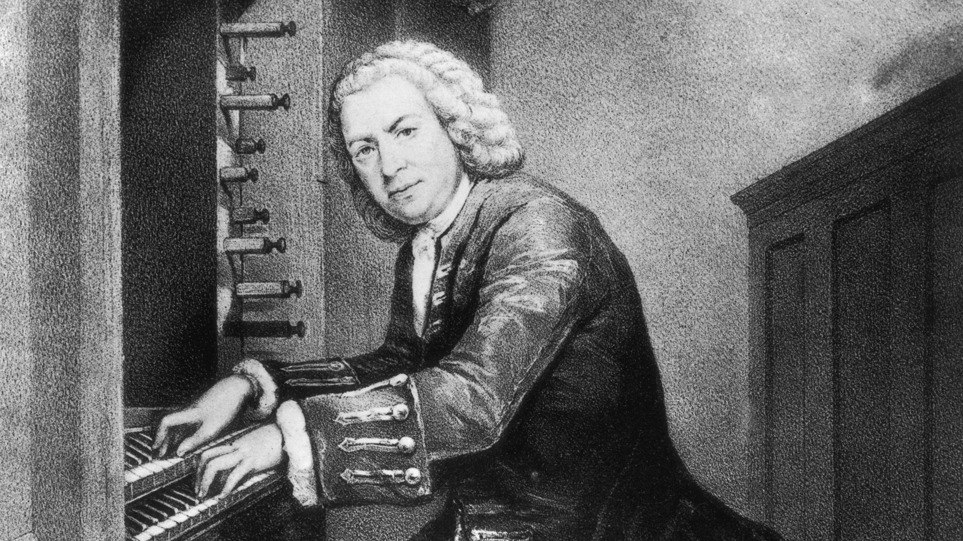
Healing & Confession:
Should you require prayer for healing, please indicate to the vicar at the altar rail during Communion so anointing with oil can be given. The confidential act of Reconciliation/Confession (see page 750 of the Prayer Book) is also available on Friday’s at the church 9am – 2pm
Hall Building Fund:
So far we have raised approx. $26,000.00 in the Building Fund towards a new church hall! This is from a Golf Tournament, two Christmas Fairs, and donations

